EX.NO:6 DATE:11.09.2024

RESTRICTING AND SORTING DATA

Find the Solution for the following:

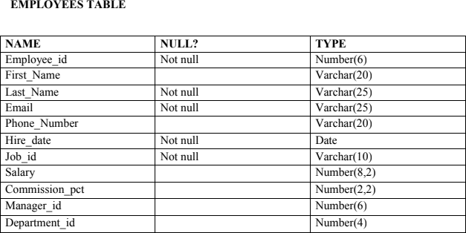

CREATE TABLE Employees (

Employee_id NUMBER(6) NOT NULL, First_Name VARCHAR(20),

Last_Name VARCHAR(25) NOT NULL, Email VARCHAR(25) NOT NULL,

Phone_Number VARCHAR(20), Hire_date DATE NOT NULL, Job_id VARCHAR(10) NOT NULL, Salary NUMBER(8,2),

Commission_pct NUMBER(2,2), Manager_id NUMBER(6), Department_id NUMBER(4)

);

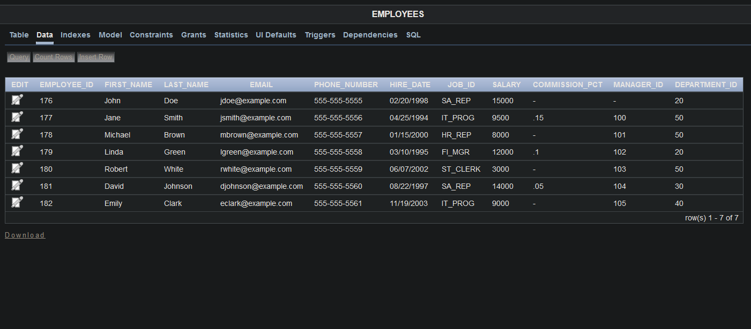

1. Create a query to display the last name and salary of employees earning more than 12000.

SELECT Last_Name, Salary FROM Employees

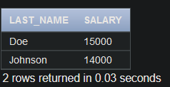WHERE Salary > 12000;

1. Create a query to display the employee last name and department number for employee number 176.

SELECT Last_Name, Department_id FROM Employees

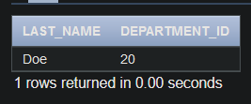WHERE Employee_id = 176;

1. Create a query to display the last name and salary of employees whose salary is not in the range of 5000 and 12000. (hints: not between )

SELECT Last_Name, Salary FROM Employees

WHERE Salary NOT BETWEEN 5000 AND 12000;

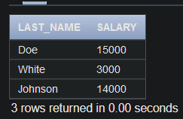

1. Display the employee last name, job ID, and start date of employees hired between February 20,1998 and May 1,1998.order the query in ascending order by start date.(hints: between)

SELECT Last_Name, Job_id, Hire_date FROM Employees

WHERE Hire_date BETWEEN TO_DATE('20-FEB-1998', 'DD-MON-YYYY') AND TO_DATE('01-MAY-1998', 'DD-MON-YYYY')

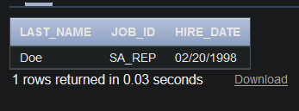ORDER BY Hire_date ASC;

1. Display the last name and department number of all employees in departments 20 and 50 in alphabetical order by name.(hints: in, orderby)

SELECT Last_Name, Department_id FROM Employees

WHERE Department_id IN (20, 50) ORDER BY Last_Name ASC;

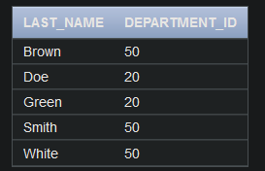

1. Display the last name and salary of all employees who earn between 5000 and 12000 and are in departments 20 and 50 in alphabetical order by name. Label the columns **EMPLOYEE, MONTHLY SALARY respectively.(hints: between, in)**

SELECT Last_Name AS EMPLOYEE, Salary AS "MONTHLY SALARY"

FROM Employees

WHERE Salary BETWEEN 5000 AND 12000

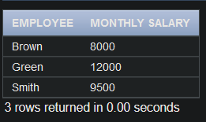AND Department_id IN (20, 50) ORDER BY Last_Name ASC;

1. Display the last name and hire date of every employee who was hired in 1994.(hints: like)

SELECT Last_Name, Hire_date FROM Employees

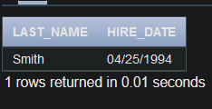WHERE Hire_date LIKE '%1994';

1. Display the last name and job title of all employees who do not have a manager.(hints: is null)

SELECT Last_Name, Job_id FROM Employees

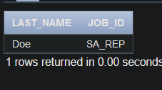WHERE Manager_id IS NULL;

1. Display the last name, salary, and commission for all employees who earn commissions. **Sort data in descending order of salary and commissions.(hints: is not nul,orderby) SELECT Last_Name, Salary, Commission_pct**

FROM Employees

WHERE Commission_pct IS NOT NULL

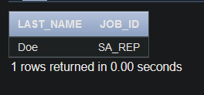ORDER BY Salary DESC, Commission_pct DESC;

1. Display the last name of all employees where the third letter of the name is a.(hints:like)

SELECT Last_Name FROM Employees

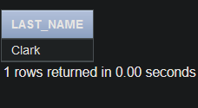WHERE Last_Name LIKE ' a%';

1. Display the last name of all employees who have an a and an e in their last name.(hints: like)

SELECT Last_Name FROM Employees

WHERE Last_Name LIKE '%a%' AND Last_Name LIKE '%e%';

1. Display the last name and job and salary for all employees whose job is sales

representative or stock clerk and whose salary is not equal to 2500 ,3500 or 7000.(hints:in,not in)

SELECT Last_Name, Job_id, Salary FROM Employees

WHERE Job_id IN ('SA_REP', 'ST_CLERK') AND Salary NOT IN (2500, 3500, 7000);

